D.E.C.R.Y.P.T User manual

Table of content

**Table of charts 4**

**Use case 5**

**Functional synoptic diagram 6**

**System architecture 6**

**1 - Sequencer board 7**

1.1 - Goals of the board 7

1.2 - Detecting the launch 9

**2 - Power board 10**

2.1- Goals of the board 10

2.2 - Features 10

**3 - Telemetry board 10**

3.1 - Goals of the board 10

Table of illustrations

fig.1: Typical scenario of rocket launching 6

fig.2 : Functional diagram 7

fig.3 : System architecture 8

fig.4 : LED board schematic and use of the different LED 10

fig.5 : Seq board electrical scheme 11

fig.6 : LED board schematic design 12

fig.7 : 2-to-4 LED control circuit using 74HC139 and 74HC04 13

fig.8 : 2 pin connector 19

fig.9 : 3 pin connector 19

fig.10 : Seq PCB 3D view 20

fig.11 : 8 pin connector 20

fig.12 : Structure of the code 21

fig.13 : Structure of the first part of the code 22

fig.14 : Structure of the second part of the code 22

fig.15 : Power board DC-DC regulation electronic scheme 24

fig.16 : Power board electronic scheme 30

fig.17 : MPU9250 37

fig.18 : BME680 38

fig.19 : Raspberry pi pico 4 40

fig 20 : HopeRF RFM98W 41

fig 21 : Forces applied on the board 45

fig 22 : Force study result 46

# Table of charts

Table 1 : LED’s goal 11

Table 2 : Truth table for driving each LED 12

Table 3 : Button’s goal 13

Table 4 : UART configuration 14

Table 5 : Servo motor to sequencer board correspondence 15

Table 6 : Typical servo motor characteristics 15

Table 7 : Pin configuration for the DC motor 15

Table 8 : DC motor driver specifications 16

Table 9 : Pin configuration for the stepper motor 16

Table 10 : Stepper motor specs 17

Table 11 : Components listing 17

Table 12 : 2 pin connector specs 18

Table 13 : 3 pin connector specs 18

Table 14 : *8 pin connector specs* 19

Table 15 : Test to realise on the Seq board 22

Table 16 : MC34063 characteristics 25

Table 17 : IRFZ44NS Mosfet characteristics 31

Table 18 : TL431 shunt regulator characteristics 32

Table 19 : LM2596S DC-DC converter characteristics 33

Table 20 : Components listing of the power board 36

Table 21 : MPU9250 specifications 37

Table 22 : MPU9250 sensors specifications 38

Table 23 : BME680 specifications 39

Table 24 : Sensor data specifications 40

Table 25 : Raspberry specifications 41

Table 26 : HopeRF specifications 42

Table 27 : Risk analysis 48

Table 28 : Work distribution 49

Table 29 : Qods’s self-evaluation 49

Table 30 : Loann’s self-evaluation 50

Table 31 : Clément’s self-evaluation 50

# Introduction

First of all, this document is intended to explain the DECRYPT project to newcomers as well as more experimented SPACE’TECH members. The DECRYPT project is born from a collaboration between 4A’s students project and SPACE’TECH Orléans.

This project is the result of a collaboration between Space’Tech Orléans, a student association, and 4A GPSE students. Space’Tech Orléans is the aerospace association of Orléans University. Every year, they participate in C’Space, an event organized by Planète Sciences that allows them to launch their rockets.

There are two types of rockets: minif, which are 1 meter tall, and fusex, which are larger, exceeding 3 meters in height and designed to carry onboard experiments. The association is mainly composed of members from TEAM, GPSE, and ICM. However, the goal is to make the electronics aspect accessible to everyone.

To ensure proper flight operations, the rockets must include electronic boards that control systems such as parachutes, motors, and data storage. To address this need, three separate boards are designed, each with specific functions. This approach not only separates functionalities but also complies with Planète Sciences' requirements.

# Use case

For the typical scenario it is important to understand that there is no access to the rocket once it is on the launching pad. Only Planète Science’s members will be able to manage the launching phase, during that phase they will test if the LED board is working properly and the parachute hatch as well. The following sketch is a quick explanatory of a typical scenario.

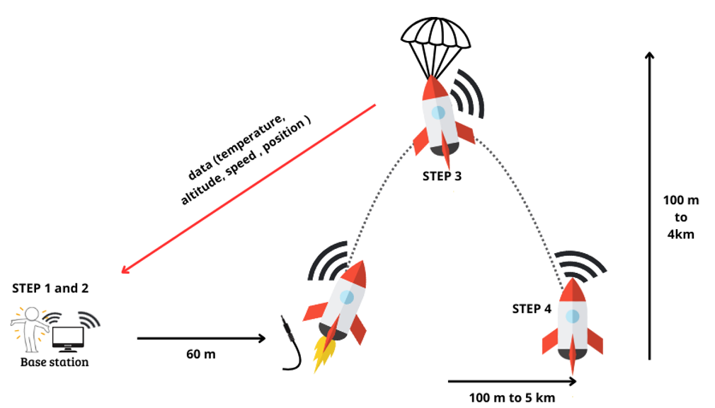

*fig.1 : typical scenario of rocket launching*

Firstly, the scenario starts on the ground when the rocket is put on the launching pad. First a switch is used to turn on the board powering. Then a jack cable is plugged on the rocket. The purpose of this jack cable is to work as an actuator, once the rocket takes off the cable is unplugged which activates board programs. Another switch is then used to open the parachute hatch and put the parachute in it. Once done the rocket can take off.

Secondly while in flight, the rocket is : gathering and stocking data using sensors. On top of that the gathered data is sent to the base station using a communication module. At last once the rocket reaches its peak the parachute is deployed.

Thirdly when the rocket lands a gps module will be activated to find the rocket, because it can sometimes land up to 5km from the base station. Making it easier to find the rocket.

# Functional synoptic diagram

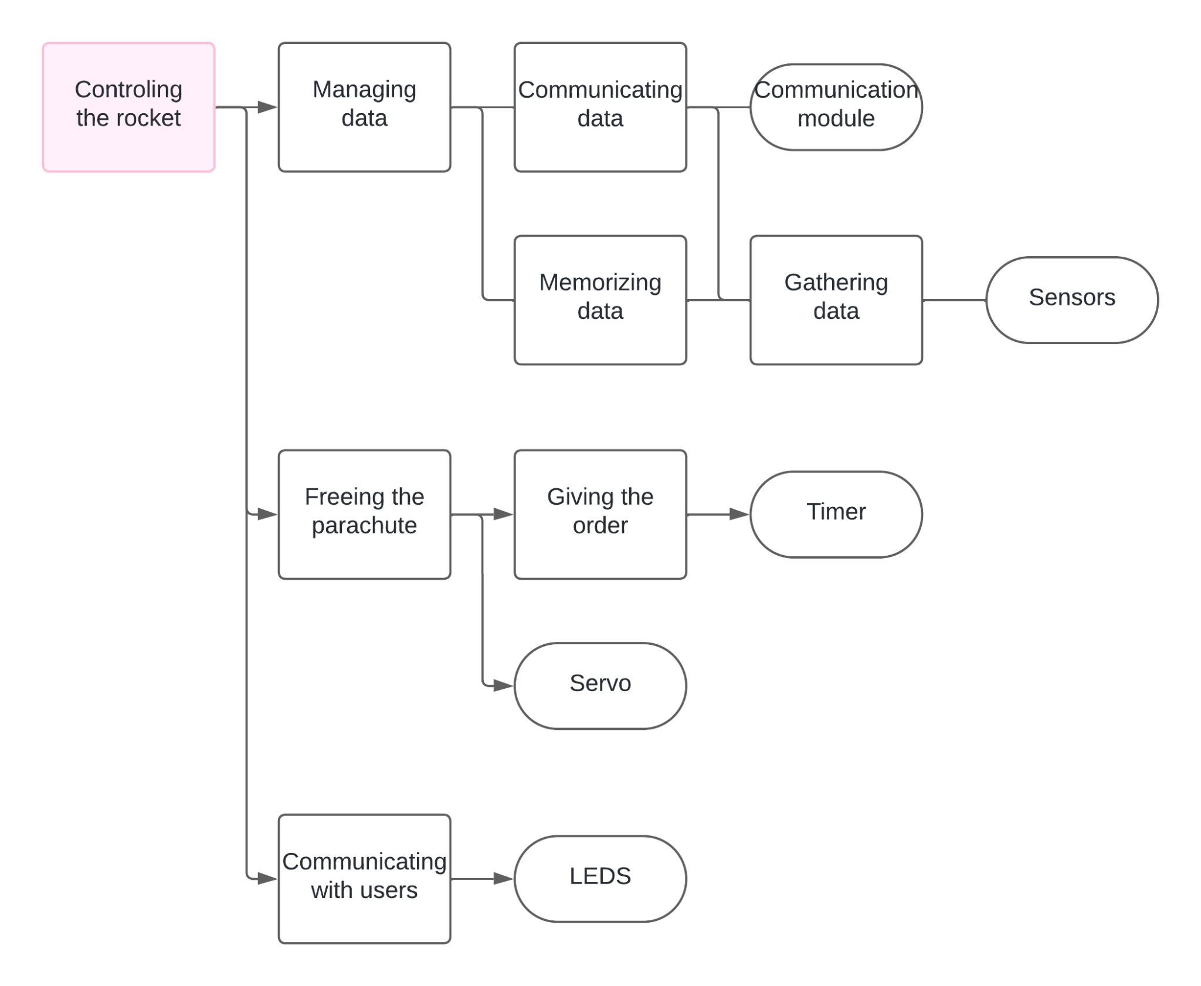

*fig.2 : Functional diagram*

# 

# 

# System architecture

The following diagram shows the architecture of the system by explaining what is gonna be used and how , in order to fulfill the functions.

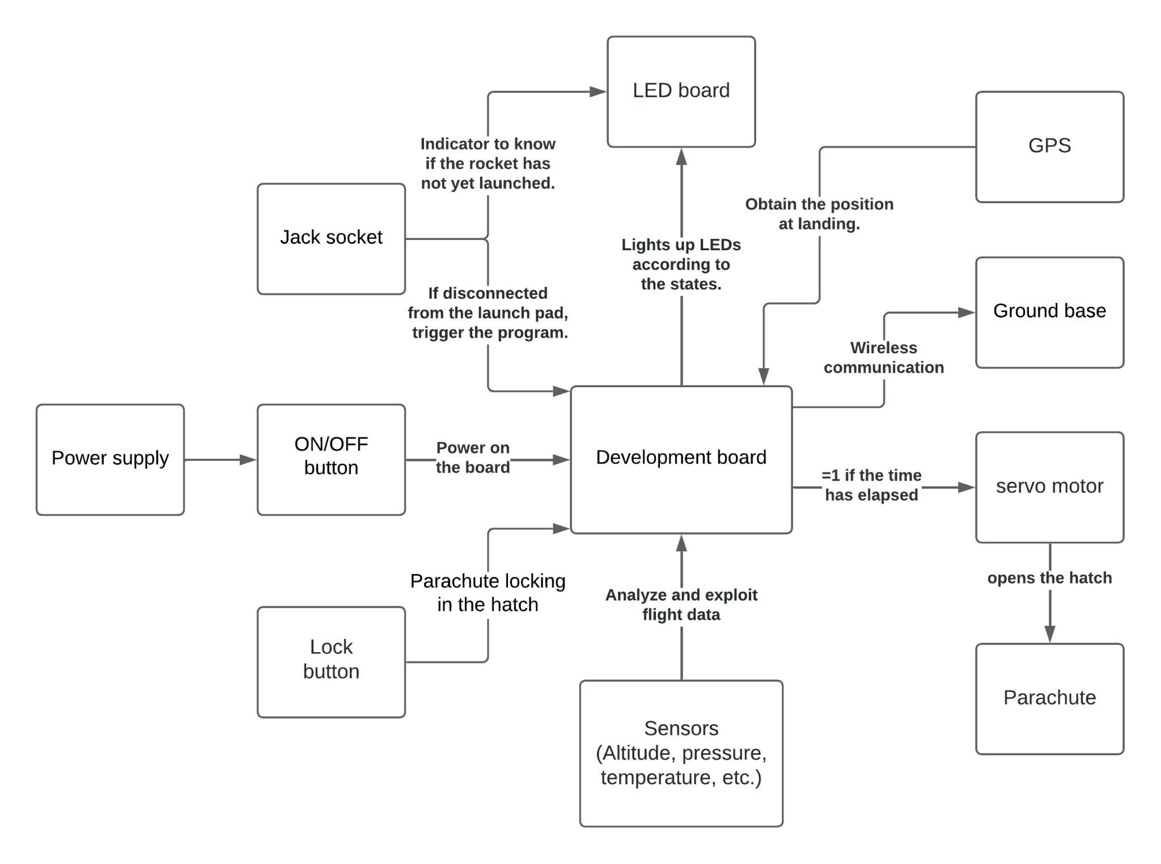

*fig.3 : System architecture*

# 1 - Goals of the boards

## 1.1 - Goals of the sequencer board

The Sequencer board is an advanced control system designed to perform three essential tasks during the rocket's flight.

1. **Parachute deployment control**

The Sequencer board plays a critical role in ensuring the rocket’s safe descent by managing the deployment of the parachute. The parachute hatch is programmed to open at a precise moment, calculated in advance based on the rocket’s expected apogee. This timestamp is loaded as a parameter into the program before launch. Additionally, to enhance safety and reliability, onboard sensors actively monitor the rocket’s behavior during flight. These sensors detect deceleration patterns associated with the apogee, serving as an additional safeguard to trigger the parachute hatch if necessary. The deployment mechanism is operated by a servo motor directly controlled by the Sequencer board to open the hatch.

1. **LED control and status communication**

The Sequencer board interfaces with an external LED board (Human Machine Interface, HIM) to visually communicate the rocket’s status. The LED board displays key operational states.  
Additionally, the LED board includes buttons for manual controls, allowing operators to close or unlock the hatch as needed. 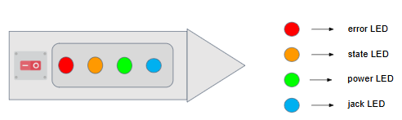

*fig 4 : LED board schematic and use of the different LED*

1. **DC/Stepper motor control for FUSEX**:

The Sequencer board includes the capability to control a DC or stepper motor, specifically designed to support functionalities in experimental rockets (FUSEX). These motors can be used for various applications, such as deploying airbrakes. activating separation mechanisms, or powering other experimental features.

## 1.2 - Detecting the launch

To reliably detect the rocket’s launch, the system uses a jack connector mechanism. During pre-launch preparation, the jack connector is inserted into a dedicated socket located on the socket’s side. When the rocket takes off, the jack cable disconnects, triggering the start of the flight sequence.

When the Arduino nano detects a low state (0) on the D2 pin, the onboard program is unlocked, initiating all the rocket’s functions. This system ensures precise activation of flight operations, eliminating the risk of premature or delayed activation of onboard components.

# 

# 

## 1.3 - Goals of the power board

The primary purpose of this board is to supply a 5 V voltage to the sequencer board and a 3.3 V voltage to the telemetry board. It also includes an additional feature that allows powering servo motors and motors with the option to select their voltage, supporting a maximum power of up to 80 W.

## 1.4 - Features

The power board is divided into two distinct sections:

* A DC-DC regulation for 5V and 3.3V
* A DC-DC regulation section for variable voltage

## 1.5 - Goals of the telemetry board

The goal of the telemetry board is to gather, store and send data. To address these functions, a development board will be embedded on the board as well as sensors and communication modules. The basic sensors will be on the board but it is possible to add new ones afterward. There is also a gps module on the board which will be needed to find the rocket if it lands far from sight. Moreover one of the underlying goals of this project is about making the system simple to understand and easy to tweak.